**Primary, Secondary, and Tertiary Colors**

* Primary – Red, Blue, Yellow
* Secondary – Purple, Green, Orange
* Tertiary – Red Purple, Blue Purple, Blue Green, Yellow Green, Orange Yellow, Orange Red

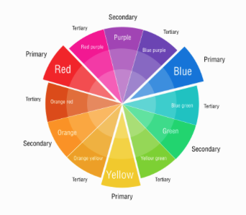



**Monochrome Colors**

Have one main color and apply a 10-90% white or black layer on top of it.



**Analogous Colors**

Picking colors near the main one on the color wheel.

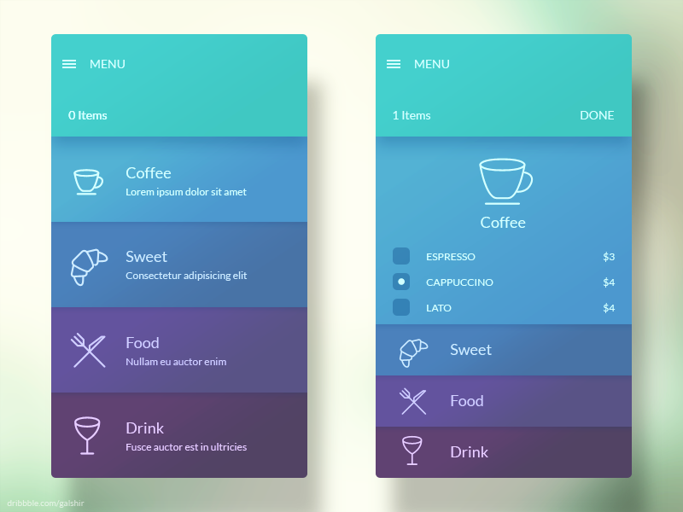

**Complementary Colors**

Using colors opposite the main one on the color wheel.



**Neutral Tones**

Drag saturation to nearly zero then change brightness to light or dark. Defers the user’s attention to the content; should not compete against the main colors.



**Split-Complementary Colors**

Uses a primary or secondary color and the two tertiary colors adjacent to its complementary color.





**Triad**

Uses 3 colors evenly spaced on the color wheel.

